NAMIBIA UNIVERSITY OF SCIENCE AND TECHNOLOGY
DSA521S — Data Structures and Algorithms 1
Group Mini-Project 2026
NUST Service Centre Simulation
Project Report — Parts A to E
Complete details are recorded in Section 1 below.
Submission deadline: 25 September 2026 @ 23:59



1. Cover Page
Project Title: NUST Service Centre Simulation — Data Structures and Algorithms Mini-Project
Course: DSA521S — Data Structures and Algorithms 1
Group Number: ______________
Group Members:
Full Name | Student Number | Parts Contributed
_________________________ | ______________ | ________________
_________________________ | ______________ | ________________
_________________________ | ______________ | ________________
_________________________ | ______________ | ________________
_________________________ | ______________ | ________________
_________________________ | ______________ | ________________

GitHub Repository: https://github.com/______________________________
Date of Submission: ____________________

2. Introduction
This project simulates the student service centre at the NUST main campus. Students arrive and wait to be assisted, are served in the order they arrived, and a record is kept of each completed service. At the end of the day the service times are analysed and sorted.
Four data structures were implemented by hand, each chosen for the specific job it does best: a queue for the waiting line, a singly linked list for service records, an array for the daily statistics, and a stack for evaluating postfix expressions. Four sorting algorithms were then implemented and compared experimentally.
No Java library collection classes and no built-in sorting methods were used anywhere in the project. Every structure and algorithm was written from first principles.

3. Data Structures (Part A)

3.1 Queue — Waiting Line
The queue is built from linked nodes. Each node holds one student and a reference to the next node. The queue itself stores three things: front (the student to be served next), rear (the most recent arrival) and size.
Keeping both a front and a rear pointer is the key design decision. It means that adding a student to the back and removing a student from the front are both O(1) operations — neither depends on how many students are already waiting.
Diagram — six students arrive, three are served
After 6 arrivals:
front rear
↓ ↓
[Maria]→[Tomas]→[Ndapewa]→[Simon]→[Helena]→[Petrus]→ null

After 3 served (removed from the FRONT):
front rear
↓ ↓
[Simon]→[Helena]→[Petrus]→ null
Students were served in exactly the order they arrived — Maria, Tomas, Ndapewa — confirming first-in-first-out behaviour.
The full program output for this demonstration can be reproduced by running java QueueDemo. The source file is StudentQueue.java in the GitHub repository.

3.2 Singly Linked List — Student Service Records
Each node stores the student number, name, service type and service time, plus a next pointer. The list stores only head and a record count.
Insertion and deletion work by re-pointing references rather than moving data. Both use a strict two-step order: point the new node forward first, then re-point what comes before it. Reversing those steps would leave nothing referencing the rest of the list.
Diagram — Operation 1: insertion at position 3
BEFORE:
head
↓
[Simon]→[Maria]→[Tomas]→[Ndapewa]→ null

Step 1: newNode.next ← current.next (Helena points at Tomas)
Step 2: current.next ← newNode (Maria now points at Helena)

AFTER:
head
↓
[Simon]→[Maria]→[Helena]→[Tomas]→[Ndapewa]→ null
Diagram — Operation 2: deletion of student 222034512
BEFORE:
head
↓
[Simon]→[Maria]→[Helena]→[Tomas]→[Ndapewa]→ null
│ ✗ ↑
└─────────────────┘
current.next ← current.next.next

AFTER:
head
↓
[Simon]→[Maria]→[Helena]→[Ndapewa]→ null
Deletion searches for the node before the target, because a singly linked list has only forward pointers — once you reach the node to be deleted you can no longer reach the one in front of it.
The full program output for this demonstration can be reproduced by running java LinkedListDemo. The source file is StudentLinkedList.java in the GitHub repository.

3.3 Stack — Postfix Expression Evaluation
The stack is array-based. top holds the index of the top item, and top = −1 means the stack is empty. Numbers are pushed; when an operator appears, two values are popped, the operation is applied, and the result is pushed back.
The order of the two pops matters. The stack returns the most recently pushed value first, which is the right-hand operand:
right ← pop() // popped FIRST = second operand
left ← pop() // popped SECOND = first operand
result ← left operator right
Trace — evaluating 5 3 + 2 *
Token | Action | Stack (bottom → top)
5 | push 5 | [ 5 ]
3 | push 3 | [ 5, 3 ]
+ | pop 3, pop 5, push 5 + 3 = 8 | [ 8 ]
2 | push 2 | [ 8, 2 ]
* | pop 2, pop 8, push 8 × 2 = 16 | [ 16 ]

Final result: 16
Two further expressions were tested: 8 2 / 3 + 4 * = 28 and 12 4 - 2 * 8 / = 2.
The full trace output, including the two additional expressions, can be reproduced by running java PostfixEvaluator. The source files are DoubleStack.java and PostfixEvaluator.java in the GitHub repository.

3.4 Array — Daily Statistics
Service times of students already served are stored in an array with a separate count of how many slots are in use. Every statistic is produced by a hand-written traversal; no max(), min() or sum() helper was used.
Results for the simulated day (service times 12, 5, 8, 4, 7, 6, 15, 11):
Statistic | Value
Total students served | 8
Total service time | 68 min
Average service time | 8.50 min
Highest service time | 15 min
Lowest service time | 4 min
Services longer than 10 min | 3

Manual verification: 12+5+8+4+7+6+15+11 = 68; 68 ÷ 8 = 8.5; highest 15; lowest 4; services over 10 minutes are 12, 15 and 11, giving 3.
Two implementation details were essential. The average casts the total to a real number before dividing, because integer division in Java would have returned 8 instead of 8.5. The highest and lowest are initialised from the first element rather than from zero — starting lowest at 0 would always return 0, since no service time is negative.
The full program output can be reproduced by running java StatisticsDemo. The source file is DailyStatistics.java in the GitHub repository.

3.5 Justification of Structure Choices (Task A5)

Queue — the waiting line
Students must be assisted in the order they arrive, and a queue is the only structure whose behaviour enforces that rule automatically. Because elements can be added only at the rear and removed only at the front, a student who arrived later cannot be served first — fairness is built into the structure rather than into extra checking code. The order of the nodes itself records the order of arrival, which is why a separate arrival-number field is unnecessary.
Our implementation keeps direct front and rear pointers, so enqueue() and dequeue() are both O(1) regardless of queue length. An array would shift every remaining student forward on each service, giving O(n) per service, and would be limited to a fixed capacity chosen in advance.

Singly linked list — service records
Records are created and removed unpredictably: at the beginning, at the end, or at a specific position. A linked list handles this without moving data — deletion is the single assignment current.next = current.next.next, which detaches a node wherever it sits. An array would shift every element after the change point, costing O(n) of data movement each time. The list also uses exactly as much memory as there are records.
The trade-off is that there is no indexed access, so searching is O(n). This is acceptable because the record list is small and the dominant operations are insertion and deletion, which is where the linked list is strongest.

Stack — postfix evaluation
Postfix evaluation needs the two most recently seen operands at the moment an operator appears, and last-in-first-out access delivers them directly. Nothing below the top two items is ever needed, so a structure that exposes only its top is a precise fit rather than a limitation. Each token costs at most two pops and one push, all O(1), allowing the whole expression to be evaluated in one left-to-right pass with no bracket matching and no operator-precedence table.

Array — daily statistics
Service times form a fixed set of values that is only read; no insertion or deletion in the middle is required, which removes the one weakness of arrays. Contiguous storage gives O(1) indexed access, so a single O(n) traversal computes every statistic. The array is also the natural input for the sorting algorithms, which depend on indexed access and in-place swapping that a linked list cannot provide efficiently.

Summary
Structure | Task | Key property used | Main operation cost
Queue | Waiting line | FIFO — enforces arrival order | enqueue / dequeue O(1)
Singly linked list | Service records | Dynamic links — no shifting | insert/delete O(1) once positioned; search O(n)
Stack | Postfix evaluation | LIFO — top two items are the operands | push / pop / peek O(1)
Array | Daily statistics | Contiguous indexed access | traversal O(n); access O(1)

4. Sorting Algorithms (Part B)
All four algorithms sort the array [17, 5, 23, 8, 14, 3, 11, 20, 6, 9] into ascending order. Counters record only comparisons between data values, never loop-index checks.
Summary of the 10-element test
Algorithm | Comparisons | Swaps / Shifts
Selection Sort | 45 | 7
Insertion Sort | 32 | 25
Merge Sort | 23 | —
Quick Sort | 20 | 15

4.1 Selection Sort
Repeatedly finds the smallest value in the unsorted remainder and swaps it to the front of that remainder. A swap is performed only when the smallest value is not already in place, which is why 7 swaps were needed rather than 9.
Pass | Array after pass | Comparisons | Swaps
Start | [17, 5, 23, 8, 14, 3, 11, 20, 6, 9] | 0 | 0
1 | [3, 5, 23, 8, 14, 17, 11, 20, 6, 9] | 9 | 1
2 | [3, 5, 23, 8, 14, 17, 11, 20, 6, 9] | 17 | 1
3 | [3, 5, 6, 8, 14, 17, 11, 20, 23, 9] | 24 | 2

Pass 2 produced no visible change because 5 was already the smallest remaining value.
The comparison count is fixed at 9 + 8 + 7 + … + 1 = 45 for any 10-element array, sorted or not. Selection sort cannot detect that its work is already done, which is why its best, average and worst cases are all O(n²).

4.2 Insertion Sort
Builds a sorted region at the front, inserting one element at a time — the way playing cards are sorted in the hand. Larger values shift one position right to open a gap, and the inner loop stops as soon as a value that is not larger is met.
Pass | Key inserted | Array after pass | Comparisons | Shifts
Start | — | [17, 5, 23, 8, 14, 3, 11, 20, 6, 9] | 0 | 0
1 | 5 | [5, 17, 23, 8, 14, 3, 11, 20, 6, 9] | 1 | 1
2 | 23 | [5, 17, 23, 8, 14, 3, 11, 20, 6, 9] | 2 | 1
3 | 8 | [5, 8, 17, 23, 14, 3, 11, 20, 6, 9] | 5 | 3

Pass 2 cost only one comparison: 23 is greater than 17, so it was already in place and the loop stopped immediately. That early exit is what allows insertion sort to approach O(n) on nearly-ordered data — confirmed dramatically in the Part C experiment.

4.3 Merge Sort
Divide and conquer, implemented recursively. The base case is a section of one element or fewer, which is already sorted; this is what terminates the recursion. Two sorted halves are then merged by comparing their front values and copying the smaller one.
Divide-and-merge diagram
[17 5 23 8 14 3 11 20 6 9]
/ \
[17 5 23 8 14] [3 11 20 6 9]
/ \ / \
[17 5 23] [8 14] [3 11 20] [6 9]
/ \ / \ / \ / \
[17 5] [23] [8] [14] [3 11] [20] [6] [9]
/ \ / \
[17] [5] [3] [11] ← BASE CASE: sections of size 1

MERGE UPWARDS:
[17] + [5] → [5 17]
[5 17] + [23] → [5 17 23]
[8] + [14] → [8 14]
[5 17 23] + [8 14] → [5 8 14 17 23]
[3] + [11] → [3 11]
[3 11] + [20] → [3 11 20]
[6] + [9] → [6 9]
[3 11 20] + [6 9] → [3 6 9 11 20]
[5 8 14 17 23] + [3 6 9 11 20] → [3 5 6 8 9 11 14 17 20 23]
Total: 23 comparisons. Merging uses ≤ rather than < so that equal values keep their original relative order, making our merge sort stable. A temporary array is allocated once and reused by every merge.

4.4 Quick Sort
Pivot-selection rule: the last element of the current section (Lomuto partition scheme).
One partition step rearranges the section so that values less than or equal to the pivot sit to its left and greater values to its right. The pivot is then in its final position and is excluded from both recursive calls.
Stage 1 — section [17, 5, 23, 8, 14, 3, 11, 20, 6, 9], pivot = 9
Left partition | [5, 8, 3, 6] — values ≤ 9
Pivot position | index 4 (final)
Right partition | [23, 11, 20, 17, 14] — values > 9
Array after stage | [5, 8, 3, 6, 9, 23, 11, 20, 17, 14]

Stage 2 — left section [5, 8, 3, 6], pivot = 6
Left partition | [5, 3] — values ≤ 6
Pivot position | index 2 (final)
Right partition | [8] — values > 6
Array after stage | [5, 3, 6, 8, 9, 23, 11, 20, 17, 14]

Totals: 20 comparisons, 15 swaps. Quick sort performed best on this array because pivot 9 produced an almost even split. Unlike merge sort it needs no temporary array, sorting in place.
The complete pass-by-pass traces for all four algorithms can be reproduced by running java SortingDemo. The source files are SelectionSort.java, InsertionSort.java, MergeSort.java and QuickSort.java in the GitHub repository.
5. Algorithm Experiment (Part C)

Test values were generated programmatically using a fixed random seed, so the experiment is repeatable. For each input size one original array was generated and every algorithm received a copy of exactly the same values. Only comparisons between data values were counted, and only the sorting call was timed.
A warm-up phase runs before timing begins. Java compiles methods to machine code only after they have executed a number of times, so without a warm-up whichever algorithm ran first would appear artificially slow. The warm-up is not timed and does not affect the recorded results.

5.1 Results — Random Arrays
Algorithm | Input Size | Number of Comparisons | Execution Time (ns)
Selection Sort | 20 | 190 | 2 369
Insertion Sort | 20 | 107 | 1 507
Merge Sort | 20 | 66 | 13 450
Quick Sort | 20 | 65 | 10 949
Selection Sort | 50 | 1 225 | 5 131
Insertion Sort | 50 | 692 | 3 660
Merge Sort | 50 | 227 | 6 800
Quick Sort | 50 | 267 | 3 622
Selection Sort | 100 | 4 950 | 9 479
Insertion Sort | 100 | 2 528 | 9 240
Merge Sort | 100 | 541 | 8 333
Quick Sort | 100 | 673 | 20 099
Selection Sort | 500 | 124 750 | 108 866
Insertion Sort | 500 | 61 796 | 169 751
Merge Sort | 500 | 3 865 | 36 051
Quick Sort | 500 | 4 565 | 35 824

Each result was verified by an isSorted() check, which confirmed ascending order in all twenty runs.

5.2 Additional Test — Almost-Sorted 100-Element Array
The 100-element array was sorted into ascending order, then five pairs of neighbouring values were swapped, at index positions 10/11, 25/26, 40/41, 60/61 and 80/81. All four algorithms received the same almost-sorted array.
Algorithm | Random 100 — Comparisons | Almost-Sorted — Comparisons | Change
Selection Sort | 4 950 | 4 950 | no change
Insertion Sort | 2 528 | 103 | −96 %
Merge Sort | 541 | 357 | −34 %
Quick Sort | 673 | 4 815 | +615 %

Algorithm | Random 100 — Time (ns) | Almost-Sorted — Time (ns)
Selection Sort | 9 479 | 4 460
Insertion Sort | 9 240 | 1 083
Merge Sort | 8 333 | 4 158
Quick Sort | 20 099 | 9 079

Screenshot 1 — the experiment running. Output of java SortingExperiment, showing the results tables above being produced, with the isSorted? column confirming every run. 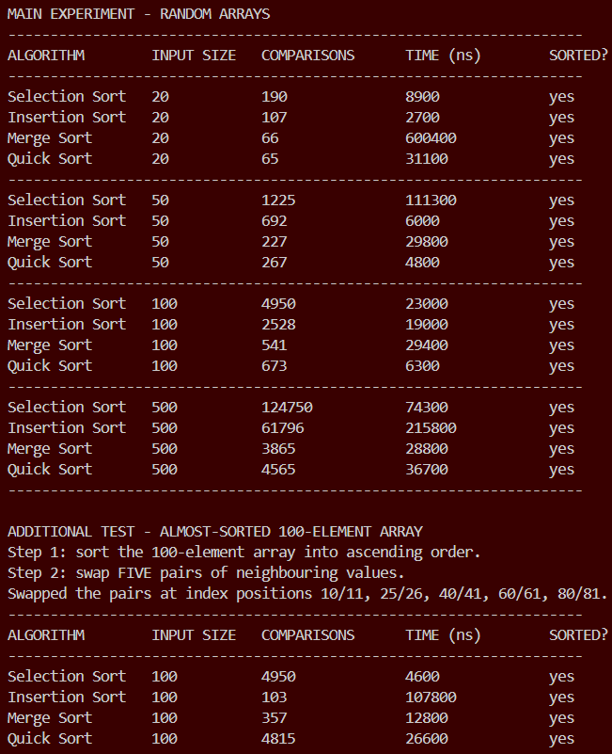

5.3 Answers to the Questions

1. Which algorithm performed the fewest comparisons?
Quick sort at the two smaller sizes, merge sort at the two larger ones. At n = 20 quick sort used 65 against merge sort's 66 — a difference of one, which is not meaningful. From n = 50 upward merge sort was consistently lowest: 227 against 267, 541 against 673, and 3 865 against 4 565.
Merge sort wins on comparison count because its division is always perfectly even, giving the theoretical minimum number of merge levels. Quick sort's division depends on the pivot, and any uneven split costs extra comparisons.

2. Which algorithm performed the most comparisons?
Selection sort, at every input size: 190, 1 225, 4 950 and 124 750 — roughly double insertion sort's figures and over thirty times merge sort's at n = 500.
Its comparison count is fixed by input size alone, n(n−1)/2, which for n = 500 is exactly 500 × 499 ÷ 2 = 124 750, matching the measured value precisely. It must scan the entire unsorted remainder on every pass and has no mechanism to stop early.
Selection sort did not record the slowest execution time at n = 500 — insertion sort did, at 169 751 ns against 108 866 ns. Selection sort performs at most n − 1 swaps, whereas insertion sort performed tens of thousands of shifts. Comparisons are cheap; moving data is expensive.

3. Which algorithm performed best on the almost-sorted array?
Insertion sort, by an enormous margin — and quick sort was the clear worst.
Insertion sort needed only 103 comparisons, down from 2 528, running in 1 083 ns. With 100 elements, 99 comparisons are the unavoidable minimum, so 103 is within four of the best possible. This is caused by the break in the inner loop: when an element is already larger than its left-hand neighbour the loop stops after a single comparison, so on nearly-ordered data the algorithm degenerates to a single pass — O(n), insertion sort's best case.
The opposite happened to quick sort, which rose from 673 to 4 815 comparisons, almost level with selection sort's 4 950. Our pivot rule is "last element of the section". On sorted data the last element is the largest, so every partition puts all n−1 remaining values on the left and none on the right. Instead of halving the problem, each stage shrinks it by one, producing n levels of recursion instead of log n — the O(n²) worst case. An almost-sorted array is the worst possible input for quick sort with a last-element pivot, which is why production implementations use a median-of-three or random pivot.
Selection sort was unchanged at 4 950, since its behaviour cannot depend on the data. Merge sort improved modestly to 357, because a merge finishes early when one half is exhausted.

4. Which algorithm appeared to scale best as the input became larger?
Merge sort and quick sort scaled best. Multiplying the input by five, from 100 to 500:
Algorithm | 100 | 500 | Growth factor | Theory predicts
Selection Sort | 4 950 | 124 750 | 25.2× | 25× (5² for O(n²))
Insertion Sort | 2 528 | 61 796 | 24.4× | 25×
Merge Sort | 541 | 3 865 | 7.1× | ≈6.8× for O(n log n)
Quick Sort | 673 | 4 565 | 6.8× | ≈6.8×

Five times the data cost the quadratic algorithms about twenty-five times the work, but cost the linearithmic ones only about seven times the work. That gap is the practical meaning of O(n²) against O(n log n), and it widens as n grows.

5. Did the experimental results generally agree with the theoretical time complexity?
Yes — the comparison counts agree almost exactly, and the execution times agree once the input is large enough.
Selection sort's O(n²) formula n(n−1)/2 predicts 190, 1 225, 4 950 and 124 750; those are precisely the measured values. Merge sort's bound n log₂n − n + 1 predicts about 3 985 for n = 500; we measured 3 865. The growth factors above match prediction to within a few percent.
The execution times agree at larger sizes but not at the smallest. At n = 20 merge sort took 13 450 ns while selection sort took 2 369 ns, apparently contradicting theory. Two effects explain this. First, constant factors dominate small inputs: merge sort allocates a temporary array and makes recursive method calls, and with only 20 elements there is not enough work to repay that overhead. Big-O describes how cost grows, not which algorithm wins on tiny inputs. Second, measurement noise: a nanosecond timer on a multitasking operating system is affected by background processes and by the JVM's just-in-time compiler.
By n = 500 the theoretical ordering is fully visible: merge sort 36 051 ns and quick sort 35 824 ns against selection sort 108 866 ns and insertion sort 169 751 ns. Theory and experiment therefore agree, and asymptotic complexity is confirmed as a statement about large inputs.

6. Is execution time alone enough to decide which algorithm is better?
No. Our own results contain three cases where execution time alone gives the wrong answer.
Execution time is not reproducible. It depends on the processor, on other work the machine is doing, on caching, and on the JIT compiler. Running the program twice produces different figures. Comparison counts were identical on every run. A measure that changes with the machine cannot by itself settle which algorithm is better.
Execution time hides why an algorithm is slow. At n = 500 insertion sort took 169 751 ns and selection sort 108 866 ns, so by time alone selection sort looks better — yet selection sort made twice as many comparisons. The gap comes from data movement. Only by counting both operations can we see that the two algorithms are slow for entirely different reasons.
A single measurement cannot reveal worst-case risk. On random data quick sort recorded 673 comparisons and looked excellent; on almost-sorted data of the same size it recorded 4 815. A group that timed only random data would have chosen quick sort and then watched it collapse on real, partly-ordered input.
Other factors a stopwatch cannot measure include memory use (merge sort needs an extra array of size n; the others sort in place), stability (merge and insertion sort preserve the order of equal values; selection and quick sort do not), and best/worst-case behaviour. The proper basis for a decision is the combination of comparison count, data-movement count, memory requirement, stability and expected input shape, with execution time as supporting evidence rather than the verdict.

6. Integrated System (Part D)
ServiceCentreSystem.java brings the queue, linked list, array and sorting algorithms together behind a single menu. The postfix stack remains a separate exercise, as specified.
Menu Option | Structure / Operation Invoked
1. Add student to waiting queue | Queue — enqueue()
2. Serve next student | Queue — dequeue()
3. Display waiting students | Queue — traversal
4. Add student service record | Singly Linked List — insertStudent()
5. Display student service records | Singly Linked List — traversal
6. Search for student record | Singly Linked List — searchStudent()
7. Remove student record | Singly Linked List — deleteStudent()
8. Display daily statistics | Array — traversal
9. Sort service times | Selection / Insertion / Merge / Quick Sort
10. Run sorting experiment | Full Part C experiment
11. Exit | Terminates the menu loop

The three structures meet at option 2. Serving a student removes them from the queue, inserts them into the linked list as a completed service record, and adds their service time to the statistics array. Options 4 and 7 keep the statistics array synchronised with the record list, so option 8 always reflects the current state of the system.
Input is read one whole line at a time and converted to a number inside a try/catch. This avoids the well-known Scanner problem in which a leftover newline from nextInt() is consumed by the following nextLine(), and it means a non-numeric entry re-prompts the user instead of crashing the program.
Six sample students are loaded at start-up so that the menu can be demonstrated immediately.

6.1 Evidence of the Working System
Screenshot 2 — the main menu. The program running, with the six sample students loaded into the waiting queue.
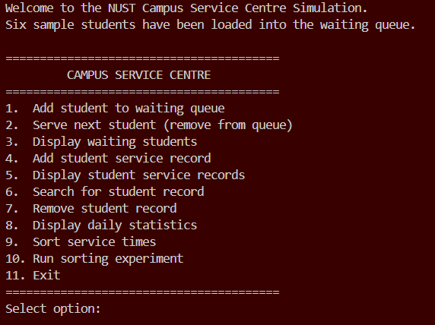
Screenshot 3 — option 2, the integration point. Serving a student: the student is removed from the queue, a service record is created in the linked list, and the service time is added to the statistics array, all from one menu selection.
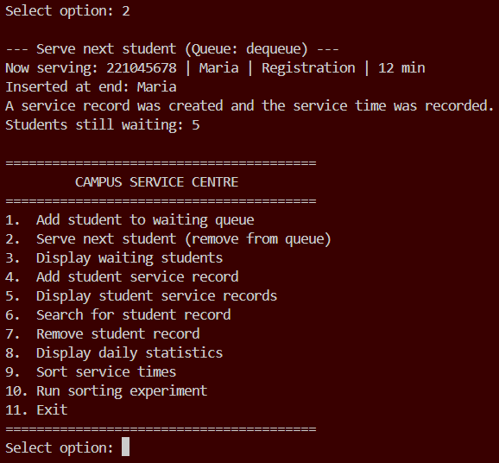
Screenshot 4 — option 8, daily statistics. The array traversal producing all six figures from the records created by option 2, demonstrating that the structures are genuinely connected rather than independent.
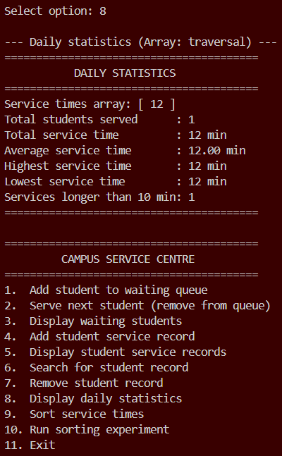
All other program output referenced in this report can be reproduced from the source files in the GitHub repository using the run commands listed in README.md.

7. Pseudocode (Part E)
Pseudocode for all required operations is provided in the accompanying document E_Pseudocode.md, covering:
- Queue: enqueue(), dequeue(), peek(), displayQueue()
- Stack: push(), pop(), peek(), postfix evaluation
- Singly Linked List: insertNode() (three variants), deleteNode(), searchNode(), traverseList()
- Array: daily statistics traversal
- Sorting: selectionSort(), insertionSort(), mergeSort(), quickSort()
- Integrated system: the main menu loop
Each block is labelled with the Java file and method it corresponds to, and the logic matches the submitted implementation line for line.

Part E — Pseudocode and Algorithm Representation [10 Marks]
Pseudocode for every operation the brief lists. Each block corresponds directly to the submitted Java implementation; the Java file and method that each one matches is named above it.
Notation used throughout:
Symbol | Meaning
← | assignment
= , ≠ | comparison (equal, not equal)
NULL | a pointer that refers to nothing
// | comment
indentation | statements belonging to the same block

1. Queue Operations

1.1 `enqueue()` — `StudentQueue.java`
ENQUEUE(student)
newNode ← create new node
newNode.data ← student
newNode.next ← NULL

IF front = NULL THEN // the queue is empty
front ← newNode
ELSE
rear.next ← newNode // link the old last node to the new one
END IF

rear ← newNode // the new node is now the last
size ← size + 1
END ENQUEUE

1.2 `dequeue()` — `StudentQueue.java`
DEQUEUE()
IF front = NULL THEN
PRINT "queue is empty"
RETURN NULL
END IF

served ← front.data // remember the student at the front
front ← front.next // move the front pointer along

IF front = NULL THEN // the last student has just left
rear ← NULL // reset rear, or it points at a removed node
END IF

size ← size − 1
RETURN served
END DEQUEUE

1.3 Supporting queue operations
PEEK()
IF front = NULL THEN RETURN NULL
RETURN front.data

IS_EMPTY()
RETURN (front = NULL)

DISPLAY_QUEUE()
IF front = NULL THEN
PRINT "waiting queue is empty"
RETURN
END IF
current ← front
position ← 1
WHILE current ≠ NULL DO
PRINT position, current.data
current ← current.next
position ← position + 1
END WHILE

2. Stack Operations and Postfix Evaluation

2.1 `push()` — `DoubleStack.java`
PUSH(value)
IF top = capacity − 1 THEN // no free slot left
PRINT "stack overflow"
RETURN
END IF

top ← top + 1 // move the top marker up
items[top] ← value // store at the new top
END PUSH

2.2 `pop()` — `DoubleStack.java`
POP()
IF top = −1 THEN // −1 means the stack is empty
PRINT "stack underflow"
RETURN 0
END IF

value ← items[top] // read the top value
top ← top − 1 // lower the top marker
RETURN value
END POP

2.3 `peek()` — `DoubleStack.java`
PEEK()
IF top = −1 THEN
PRINT "stack is empty"
RETURN 0
END IF
RETURN items[top] // read WITHOUT changing top
END PEEK

2.4 Postfix evaluation — `PostfixEvaluator.java`
EVALUATE_POSTFIX(expression)
tokens ← split expression on spaces
create empty stack

FOR each token IN tokens DO
IF token is a number THEN
PUSH(convert token to number)
ELSE // token is an operator
right ← POP() // popped FIRST = second operand
left ← POP() // popped SECOND = first operand

IF token = "+" THEN result ← left + right
ELSE IF token = "−" THEN result ← left − right
ELSE IF token = "×" THEN result ← left × right
ELSE // division
IF right = 0 THEN
PRINT "error: division by zero"
result ← 0
ELSE
result ← left ÷ right
END IF
END IF

PUSH(result)
END IF
END FOR

RETURN POP() // one value remains: the answer
END EVALUATE_POSTFIX
The order of the two pops is essential. The stack returns the most recently pushed value first, which is the right-hand operand. Reversing these two lines would produce correct results for addition and multiplication but wrong results for subtraction and division.

3. Singly Linked List Operations

3.1 `insertNode()` — `StudentLinkedList.java`
Three insertion variants are required by the brief. All three use the same two-step re-linking rule: point the new node forward first, then re-point what comes before it.
INSERT_AT_BEGINNING(student)
newNode ← create node with student
newNode.next ← head // step 1: new node points at the old first node
head ← newNode // step 2: head moves to the new node
count ← count + 1
END INSERT_AT_BEGINNING

INSERT_AT_END(student)
newNode ← create node with student
newNode.next ← NULL

IF head = NULL THEN
head ← newNode
ELSE
current ← head
WHILE current.next ≠ NULL DO // walk to the LAST node
current ← current.next
END WHILE
current.next ← newNode
END IF

count ← count + 1
END INSERT_AT_END

INSERT_AT_POSITION(student, position)
IF position < 1 OR position > count + 1 THEN
PRINT "invalid position"
RETURN
END IF

IF position = 1 THEN
INSERT_AT_BEGINNING(student)
RETURN
END IF

newNode ← create node with student
current ← head
FOR i ← 1 TO position − 2 DO // stop on the node BEFORE the target slot
current ← current.next
END FOR

newNode.next ← current.next // step 1
current.next ← newNode // step 2
count ← count + 1
END INSERT_AT_POSITION

3.2 `deleteNode()` — `StudentLinkedList.java`
DELETE_NODE(studentNo)
IF head = NULL THEN
PRINT "list is empty"
RETURN FALSE
END IF

// Case 1: the record to delete is the head
IF head.data.studentNo = studentNo THEN
head ← head.next
count ← count − 1
RETURN TRUE
END IF

// Case 2: search for the node BEFORE the target
current ← head
WHILE current.next ≠ NULL AND current.next.data.studentNo ≠ studentNo DO
current ← current.next
END WHILE

IF current.next = NULL THEN // reached the end without finding it
PRINT "student not found"
RETURN FALSE
END IF

current.next ← current.next.next // bypass the target node
count ← count − 1
RETURN TRUE
END DELETE_NODE
The search deliberately looks one node ahead. A singly linked list has only forward pointers, so once you are standing on the node to be deleted you can no longer reach the node in front of it.

3.3 `searchNode()` — `StudentLinkedList.java`
SEARCH_NODE(studentNo)
current ← head
position ← 1

WHILE current ≠ NULL DO
IF current.data.studentNo = studentNo THEN
PRINT "found at position", position
RETURN current.data
END IF
current ← current.next
position ← position + 1
END WHILE

PRINT "student not found"
RETURN NULL
END SEARCH_NODE

3.4 `traverseList()` — `StudentLinkedList.java`
TRAVERSE_LIST()
IF head = NULL THEN
PRINT "no service records"
RETURN
END IF

current ← head // temporary pointer; head must not move
position ← 1

WHILE current ≠ NULL DO
PRINT position, current.data
current ← current.next
position ← position + 1
END WHILE

PRINT "total records:", count
END TRAVERSE_LIST

4. Array Processing — Daily Statistics
DailyStatistics.java. Included because Part A4 is an algorithmic traversal, and Part D menu option 8 calls it.
CALCULATE_STATISTICS(serviceTimes, count)
IF count = 0 THEN
PRINT "no service times recorded"
RETURN
END IF

total ← 0
highest ← serviceTimes[0] // start from a REAL element, not 0
lowest ← serviceTimes[0]
longServices ← 0

FOR i ← 0 TO count − 1 DO
total ← total + serviceTimes[i]
IF serviceTimes[i] > highest THEN highest ← serviceTimes[i]
IF serviceTimes[i] < lowest THEN lowest ← serviceTimes[i]
IF serviceTimes[i] > 10 THEN longServices ← longServices + 1
END FOR

average ← total / count // real division, NOT integer division

PRINT count, total, average, highest, lowest, longServices
END CALCULATE_STATISTICS

5. Sorting Algorithms

5.1 `selectionSort()` — `SelectionSort.java`
SELECTION_SORT(arr, n)
FOR i ← 0 TO n − 2 DO
minIndex ← i // assume position i holds the smallest

FOR j ← i + 1 TO n − 1 DO
comparisons ← comparisons + 1 // DATA comparison
IF arr[j] < arr[minIndex] THEN
minIndex ← j
END IF
END FOR

IF minIndex ≠ i THEN // skip the swap if already in place
temp ← arr[i]
arr[i] ← arr[minIndex]
arr[minIndex] ← temp
swaps ← swaps + 1
END IF
END FOR
END SELECTION_SORT

5.2 `insertionSort()` — `InsertionSort.java`
INSERTION_SORT(arr, n)
FOR i ← 1 TO n − 1 DO // element 0 is already a sorted region
key ← arr[i] // save before shifting overwrites it
j ← i − 1

WHILE j ≥ 0 DO
comparisons ← comparisons + 1 // DATA comparison
IF arr[j] > key THEN
arr[j + 1] ← arr[j] // shift the larger value right
shifts ← shifts + 1
j ← j − 1
ELSE
BREAK // correct position found - stop early
END IF
END WHILE

arr[j + 1] ← key // drop the key into the gap
END FOR
END INSERTION_SORT
The BREAK is what makes insertion sort O(n) on almost-sorted data.

5.3 `mergeSort()` — `MergeSort.java`
MERGE_SORT(arr, left, right)
IF left ≥ right THEN // BASE CASE: 0 or 1 element
RETURN
END IF

mid ← (left + right) / 2 // DIVIDE

MERGE_SORT(arr, left, mid) // sort the left half
MERGE_SORT(arr, mid + 1, right) // sort the right half
MERGE(arr, left, mid, right) // COMBINE
END MERGE_SORT

MERGE(arr, left, mid, right)
FOR i ← left TO right DO
temp[i] ← arr[i] // copy the section being merged
END FOR

i ← left // reader for the left half
j ← mid + 1 // reader for the right half
k ← left // writer into the original array

WHILE i ≤ mid AND j ≤ right DO
comparisons ← comparisons + 1 // DATA comparison
IF temp[i] ≤ temp[j] THEN // ≤ keeps equal values in order (stable)
arr[k] ← temp[i]
i ← i + 1
ELSE
arr[k] ← temp[j]
j ← j + 1
END IF
k ← k + 1
END WHILE

WHILE i ≤ mid DO // leftovers from the left half
arr[k] ← temp[i]
i ← i + 1
k ← k + 1
END WHILE

WHILE j ≤ right DO // leftovers from the right half
arr[k] ← temp[j]
j ← j + 1
k ← k + 1
END WHILE
END MERGE

5.4 `quickSort()` — `QuickSort.java`
QUICK_SORT(arr, low, high)
IF low ≥ high THEN // BASE CASE: 0 or 1 element
RETURN
END IF

pivotIndex ← PARTITION(arr, low, high)

QUICK_SORT(arr, low, pivotIndex − 1) // left partition
QUICK_SORT(arr, pivotIndex + 1, high) // right partition
// the pivot itself is already final
END QUICK_SORT

PARTITION(arr, low, high)
pivot ← arr[high] // PIVOT RULE: last element of the section
i ← low − 1 // end of the "≤ pivot" region (empty)

FOR j ← low TO high − 1 DO
comparisons ← comparisons + 1 // DATA comparison
IF arr[j] ≤ pivot THEN
i ← i + 1
swap arr[i] and arr[j]
swaps ← swaps + 1
END IF
END FOR

swap arr[i + 1] and arr[high] // pivot into its FINAL position
swaps ← swaps + 1

RETURN i + 1
END PARTITION

6. Integrated System — Main Menu Loop
ServiceCentreSystem.java, Part D.
MAIN()
create waitingQueue, serviceRecords, statistics
running ← TRUE

WHILE running DO
DISPLAY_MENU()
choice ← read a whole number from the user

CASE choice OF
1 : read student details; ENQUEUE(student)
2 : student ← DEQUEUE()
IF student ≠ NULL THEN
INSERT_AT_END(student) // create a service record
ADD_SERVICE_TIME(student.serviceTime)
END IF
3 : DISPLAY_QUEUE()
4 : read student details; INSERT_NODE(student, chosen position)
5 : TRAVERSE_LIST()
6 : read studentNo; SEARCH_NODE(studentNo)
7 : read studentNo; DELETE_NODE(studentNo)
8 : CALCULATE_STATISTICS(serviceTimes, count)
9 : times ← copy of service times
run the chosen sorting algorithm on the copy
PRINT sorted result, comparisons, swaps/shifts
10: RUN_SORTING_EXPERIMENT()
11: running ← FALSE
OTHERWISE : PRINT "invalid option"
END CASE
END WHILE
END MAIN
Option 2 is the point where three structures meet: a student is removed from the queue, inserted into the linked list as a service record, and their service time is added to the statistics array.

Checklist Against the Brief
Required operation | Section above | Java file
Queue: enqueue() | 1.1 | StudentQueue.java
Queue: dequeue() | 1.2 | StudentQueue.java
Stack: push() | 2.1 | DoubleStack.java
Stack: pop() | 2.2 | DoubleStack.java
Stack: postfix evaluation | 2.4 | PostfixEvaluator.java
Linked List: insertNode() | 3.1 | StudentLinkedList.java
Linked List: deleteNode() | 3.2 | StudentLinkedList.java
Linked List: searchNode() | 3.3 | StudentLinkedList.java
Linked List: traverseList() | 3.4 | StudentLinkedList.java
Sorting: selectionSort() | 5.1 | SelectionSort.java
Sorting: insertionSort() | 5.2 | InsertionSort.java
Sorting: mergeSort() | 5.3 | MergeSort.java
Sorting: quickSort() | 5.4 | QuickSort.java

8. Conclusion
Every structure in this project was chosen for a property the task actually needed. The queue enforces first-come-first-served ordering without extra checking code. The linked list absorbs unpredictable insertions and deletions without shifting data. The stack supplies the two most recent operands exactly when a postfix operator needs them. The array gives the constant-time indexed access that both the statistics and the sorting algorithms rely on.
The sorting experiment confirmed the theory quantitatively rather than only in principle: five times the input cost the O(n²) algorithms twenty-five times the work and the O(n log n) algorithms seven times the work, matching prediction to within a few percent. It also produced two results worth more than the tables themselves — insertion sort finishing an almost-sorted array in 103 comparisons, and quick sort with a last-element pivot degrading from 673 to 4 815 comparisons on the same data. Together they show that the right algorithm depends on the shape of the input, not on a single benchmark figure.

9. GitHub Repository
Repository URL: https://github.com/______________________________
The repository contains the full commit history of the project, with contributions from all group members.
Member | GitHub Username | Number of Commits
_________________________ | ______________ | ______
_________________________ | ______________ | ______
_________________________ | ______________ | ______
_________________________ | ______________ | ______
_________________________ | ______________ | ______
_________________________ | ______________ | ______

---------------------------------------------------------------------------------------------------

Appendix — Files Submitted

File | Part
Student.java | Shared data class
StudentQueue.java, QueueDemo.java | A1 — Queue
StudentLinkedList.java, LinkedListDemo.java | A2 — Singly Linked List
DoubleStack.java, PostfixEvaluator.java | A3 — Stack / postfix
DailyStatistics.java, StatisticsDemo.java | A4 — Array statistics
SelectionSort.java | B1
InsertionSort.java | B2
MergeSort.java | B3
QuickSort.java | B4
SortingDemo.java | B1–B4 combined demonstration
SortingExperiment.java | C — timing experiment
ServiceCentreSystem.java | D — integrated menu system
README.md | Submission details

The complete Java source code is not reproduced in this report, as required by the brief. It is submitted separately in the project ZIP and is available in the GitHub repository.

